## Exp. 2 Design an LED Chaser

Circuit Diagram:

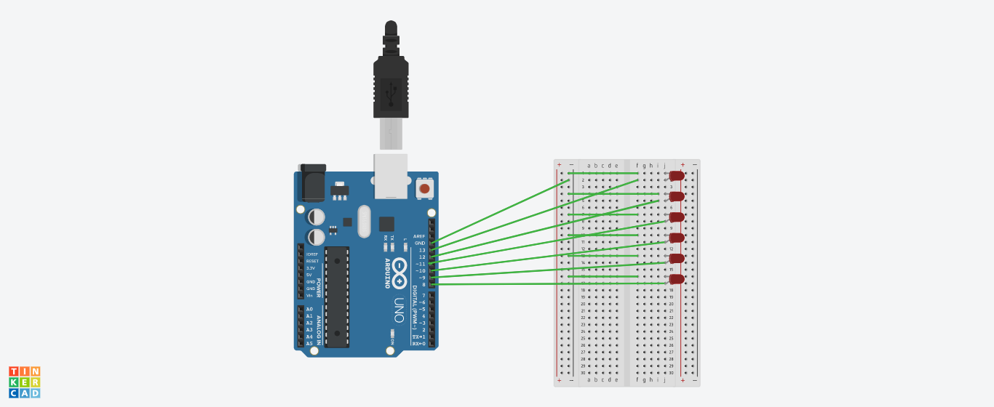

Theory

Concept Used : In led chaser ,The LEDs lights one by one for a period of 1second and the cycle repeats giving the running light appearance.

Learning & Observations:

The led light glow one by one as shown like one chasing other.

Problems & Troubleshooting:

1. Problem in fixing wire from bread board to arduino.
2. Problem in doing arduino programming.

Precautions:

1. Correct conection of negative and positive terminal of led.
2. Don’t put arduino near water.
3. Check the USB port of computer is working .
4. Check the arduino software and select the correct port (in which arduino is connected).

Learning Outcome:

1. LED light glow in the sequence of 13,12,11,10,9,8.
2. Arduino function as a controller in led chaser.
3. Bread board is used to organize the circuit.